

Structured System Analysis and Design

Project Name: E-Forms Tracking and Incident Management System

Deliverable 1: Baseline Project Plan and Statement of Work

Group 3

Contents

Introduction 3

Possible Solutions 9

Feasibility Analysis 13

Management Issues 20

Miscellaneous 21

Scope of Work 22

References 24

Addressing Comments from D0 25

# Introduction

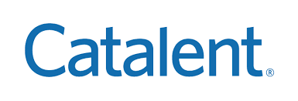

"Catalent" is a global pharmaceutical company that provides delivery technologies, development, medicine production, biologics, gene therapies, and consumer health products. The company was founded in 2007. This international firm's headquarters are in Somerset, New Jersey. It employs over 17000 people, with approximately 2500 scientists and technicians. It's a profitable business, with revenue of more than $3 billion in the preceding fiscal year. Every year, Catalent launches about 150 new products. Its flexible production platforms at more than 50 locations annually supply more than 70 billion doses of more than 7,000 products to more than 1,000 clients. Their goal is to design, develop, and market products that help people live happier, healthier lives.

Furthermore, they aspire to be the best. Its mission is to create, manufacture, and distribute items that assist people in living better, healthier lives. Furthermore, they aim to be the world's most trusted, dependable, and innovative drug development and delivery partner by upholding the highest industry standards and exceeding client expectations while driving the company's robust and sustained growth.

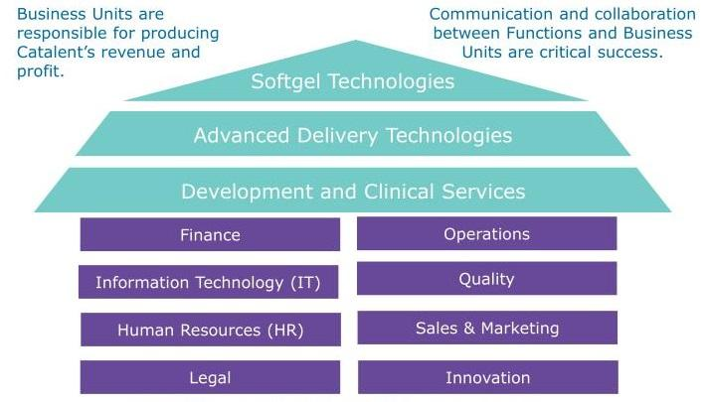

Catalent’s Organizational Structure

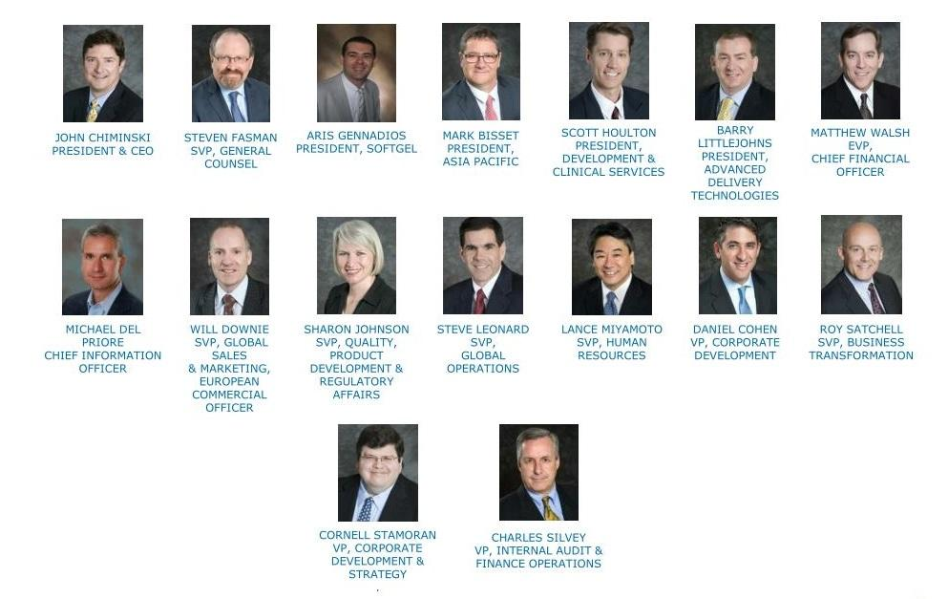

Catalent’s Organizational Structure (Executive leadership Team)

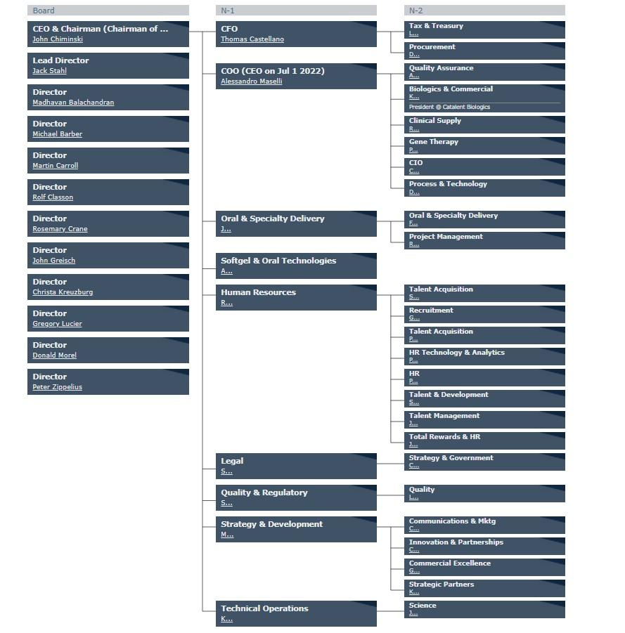

The Catalent’s Organizational Structure in detail

(*Since the organizational structure chart of Catalent is big, it is drawn horizontally*)

**Organization contact:**

Chair & Chief Executive Officer: John Chiminski

Website: https://www.catalent.com/

Address: 14 Schoolhouse Road, Somerset, NJ 08873

Contact Number: +1 877-587-1835

employees of Catalent: Hamza Chaudhry (hamza.chaudhry@catalent.com)

**Detailed Problem Statement:**

Before Covid, the Catalent pharma solutions used paper-based documents for approval and traditional methods for resolving the incident and maintaining the quality of the process. The typical technique for incident management and rectification activities is to contact the organization's help desk, which will be forwarded to the IT team, who will assist in resolving the incident by rectifying the issue at their desk or in the organization's systems. Due to the covid-19 pandemic, Catalent allowed their employees to start working remotely and not need to be on-site unless needed. They noticed a bottleneck in document approvals and inefficiency in handling the incidents and quality of the process which would impact the productivity and workflow of the organization. Many users started raising random incidents regarding connectivity due to remote work. Where employees were losing a major part of their working hours in resolving the technical issues.

Currently, Catalent uses DocuSign as their system for document approvals. They simply route it to the next person. However, there are some issues with using DocuSign. Like:

* Not everyone in the company has access to it.
* It is not secure.
* There is no access to a document's workflow and history.
* Sending DocuSign to the next person is time-consuming.
* Due to mentioned issues with DocuSign, our goal is to remove this impediment and streamline their process.

Every sector, including Catalent pharma, has several occurrences reported daily. Catalent Pharma is now inefficiently managing all incidents and quality management concerns with the traditional method. The incidents that have been mentioned are not being handled correctly. To fix the challenges, they must devote a significant amount of time and money. Every issue is referred to the appropriate department for study, and senior management permission is required, which is a time-consuming procedure. Many events are reported to the service desk, which subsequently forwards them to the appropriate personnel. Frequently, service desk personnel are ignorant of the problems and route occurrences to the incorrect teams or support. Directly affecting the quality and amount of work done by several teams tasked with resolving the problem. This results in a waste of time and resources.

**Scope of Project:**

Employees at Catalent Pharmaceutical Solutions today suffer a backlog in document approvals, incident management, and quality management because of this project. Catalent used to be a paper-based corporation, but by becoming remote, they were able to incorporate DocuSign. DocuSign, on the other hand, has had challenges. Many staff do not have DocuSign access and requesting an account can be time-consuming. Additionally, incident management is done in an ineffective manner utilizing the traditional method. Unnecessary occurrences are reported to many technical teams, wasting their precious time.

We can free up bottlenecks and make document approvals go much more smoothly by implementing the modules provided in MasterControl. To save resources and time, incidents can be handled more efficiently by referring them to the appropriate resolution group in the first place. So, using the same program, MasterControl, we can tackle many challenges. This frees up time, money, and resources for the business to spend on purchasing and maintaining new software.

This program will have an impact on all departments within the business that require form and document approvals. It will have an impact on all Catalent locations, including remote workers. Because everyone in this firm utilizes forms, the recommended solution will benefit everyone. It will be especially beneficial to project managers and executives, as many initiatives require paperwork clearance from subject matter experts from several departments.

MasterControl's incident management and corrective action module can track issues that might possibly develop into corrective measures. Routing, notification, delivery, escalation, and approval of remedial measures may all be automated, and all corresponding paperwork can be securely stored. Stakeholders will be able to obtain data on the number of document approvals, as well as information on concerns that have been raised and handled, as well as the overall efficiency of the process.

You may get to the MasterControl incident creation page from the current system incident. The end-user can choose the difficulty they're having from a drop-down menu. Depending on earlier instances with greater descriptions, the incident page's details may be available. Furthermore, they can supply further information about the concerns in the same format. The same data may then be utilized to forward the incident to the appropriate resolution team. For each new occurrence, a unique incident ID with all the data will be produced, making tracking very simple for the end-user. The end-user will receive a message with the same data when the issue is updated or resolved. They will be able to submit comments once more.

**Recommendations:**

Our team decided to go ahead with the project. The reason is that this bottleneck of document approvals and incident management can result in project delays and missed deadlines. It can also hinder other work that teams have committed to. Our decision to go with MasterControl's electronic forms and incident and corrective action modules are justified because it's already software they use in the house. MasterControl is an onboarding tool that all employees have access to. Therefore, there is no need to put in tickets for access, unlike other options such as DocuSign and traditional method. Since this is a system that is already in use, the cost to unlock this module and release it into production can be less than introducing a new system. Another advantage is that users may already be familiar with MasterControl. Therefore, there won't be an impediment of training or any pushback from users.

# Possible Solutions

Providing a secure, real-time, and cost-efficient system based on the company information technology resources.

| **Possible Solution** | **Scope/Capabilities** | **Pros** | **Cons** |
| --- | --- | --- | --- |
| MasterControl | This tool is not only used for documentation track it is also used for Training, Audit, incident management, corrective actions, and onboarding purposes. | Cost-efficient, secure, defining layer of access, access to the history of the process, Online, Process Automation can be achieved. | Technical support might be an issue and time-consuming process. |
| DocuSign | allows you to upload and e-Sign a wide range of file formats, including PDFs and Word documents, as the leading eSignature brand. | Online,  Easy to Use | Time-consuming, licenses cost, security. |
| Email Approval | Email allows you to receive/send documents at any place and any time. | Cost-efficient | The process is time-consuming.  Tracking approval is difficult. |
| Adobe PDF | Adobe Acrobat is one of the PDF applications that was pioneered by Adobe systems. This software allows you to view PDFs offline and online. It also allows you to create, edit, manage, and print PDF files with ease. | Online, Easy to use, Cost-efficient | The process is Time-consuming. Must have an account to sign the docs.  No Multi-level approvals |
| Google Docs | It is an online word processor which is accessible via an internet browser or a web-based application. It allows users to create and edit documents online while collaborating with other users in real-time. | Saves the cost to create and edit documents, can use it to invite suggestions on a particular subject | No document tracking, complex permission system, no rich media options, very few security options, no code blocks. |
| SAP | An end-user can produce an incident message when an issue arises in the SAP system. The Incident Management process is responsible for resolving events reported by end users, monitoring service alerts, or key users. | Automation of incident management is available.  End to end root analysis performance possible. | Complex Software.  Requires expert personnel. |
| ServiceNow | ServiceNow is a cloud-based IT service management application. Document management and Incident management are possible. | Customization to the greatest degree possible is conceivable. | Expensive and requires expert personnel. |
| Salesforce | Salesforce is the customer relationship management (CRM) platform. It helps marketing, sales, commerce, service, and IT teams work. | Customization to the greatest degree possible is conceivable. | Expensive and requires expert personnel. |
| Inhouse development | Can be developed and customized according to the business requirement, can integrate third-party APIs. | Develop only the required modules without complex architectures. Can design the tool with a good user experience since it is an in-house project. | High budget, Resources planning, time-consuming. |

There are many possible solutions to solve the bottleneck in the approval of documents. First comes DocuSign, an online-based electronic signature approvals system(software) currently used in the organization for document approval. It has features to create a request form and approve the requested form. The problem with using this interface is that it doesn’t provide access to every employee, is time-consuming, has issues of security, and has costs for licensing the software. The second solution for the problem is Email approval. It is cost-efficient and one of the most used methods for approval. There are a few drawbacks to this method. The tracking of the approval is difficult and a time-consuming process. Adobe PDF is the solution to the problem. It is one of the PDF applications that was pioneered by Adobe systems. This software allows you to view PDFs offline and online. It also allows you to create, edit, manage, and print PDF files with ease. It is easy to use and cost-efficient. There are a few disadvantages to this solution. It requires an account to access the documents, has a requirement of having an account in adobe mandatory, and does not support multi-level approvals. Another solution for the problem is Google Docs. It is an application that acts as a workspace to create, edit, and share documents. It is cost-efficient and can share documents with ease for approval. There are a few downsides to using this solution. It doesn’t support document tracking, has a complex permission system, minimal security, and has limited media options.

One of the solutions for incident management and correction actions is SAP (Systems, Applications, and Products in Data Processing). It has capabilities like incident management automation and end-to-end root analysis performance. This technique has drawbacks, such as complicated software and the need for professional employees. ServiceNow, a cloud-based IT service management platform, is the second solution for incident management and corrective actions. This method fully facilitates customization. These options have a few disadvantages. It is costly and necessitates the use of specialized people. SalesForce, a customer relationship management tool, is another option for issue management and corrective measures. The advantage of choosing this platform is that it allows for as much customization as possible. The disadvantage of adopting this platform is that it necessitates the use of specialized experts and is costly. In-House Development is the next option. This solution can be used for document approvals as well as incident management and rectification measures. In this solution, the organization's system analysts and IT team collaborate to design a system that meets the organization's needs. The benefit of choosing this solution is that it only builds the essential modules, with no complex architecture, a decent and interactive user experience, and the ability to integrate with third-party APIs. The disadvantage of employing this approach is that it is expensive and requires specialized staff.

Master Control is a quality management system that can be used for multiple purposes. This system has modules including Document housing, Audit reporting, User training, CAPAs/SCARs, deviations, incident management and corrective actions, change control, etc. One of the main modules happens to be electronic form tracking. This software is an integral part of the organization and can be used for onboarding purposes.

# Feasibility Analysis

**Economic Feasibility:**

The tangible costs that affect the project are MasterControl Complete Package Licenses and consultation fees. The tangible costs for this project will approximately be around $34500 per year. The first two sessions would be around $500 going up to $5000 for 8-10 sessions.

The total cost of the project would be around $345000.

Streamlining, tracking, and faster approval of documents, faster reaction and resolution of incidents reported, quality management, enhanced work productivity, and time savings are the intangible expenses for the proposed solution, Master Control.

| **Item** | **Details** | **Cost** |
| --- | --- | --- |
| MasterControl Complete Package Licenses Consultation Fees | Complete package with 5 licenses with all basic services. Which includes maintenance, business support | $ 25000 per Year |
| Cost for features | For each feature | $5000 per Year |
| User End Training | 1-2 Sessions | $500 |
| 3-4 Sessions | $1500 |
| 5-7 Sessions | $2500 |
| 8-10 Sessions | $5000 |

The proposed solution is economically feasible because of the following factors:

1. Catalent's existing incident resolution method is traditional and time-consuming, taking almost as long as it takes to resolve incidents and obtain document approvals. This results in a waste of resources and time on their part.
2. The offered approach solves both problems. They will be able to add more modules in the future and save even more time. MasterControl is already used by Catalent. This is the most cost-effective way for them to save money.
3. Catalent is wasting more resources and money in the present technique than they will pay to activate the two additional modules. The long-term benefit is far greater than the standard way.

**Technical Feasibility:**

The technology we are going to use is already available, and the project team can handle the tool. The tool is user-friendly with a good user experience; even non-technical users get to use the tool with little training. MasterControl has security in place, so those with a need to know have access to their documents while blocking other departments from seeing the content of others. In addition, all actions are recorded in an audit trail for users and documents. The incident raised via MasterControl can be tracked and will be in the database forever. On the creation of an incident, MasterControl can handle the incident to reroute it to the correct resolver group. If any issue occurs frequently, the CAPA integrated system will be used automatically to auto-resolve the incident.

If the tool is down or has an issue, it must be reported to the IT team, and this team must contact the MasterControl support team. This process may interrupt the company's day-to-day operations due to the time taken for the support team to resolve the issue.

Size of the department which affects by using this tool: This tool affects the whole company since all employees will have access as Catalent transitions from paper-based documents to electronic documents.

**Operational Feasibility:**

MasterControl removes the need for bookshelves of binders throughout multiple sites. Keeping all the binders up to date is a manual process and takes time, space, and lots of duplication of paper. There is an electronic copy available to those who need it from any device in the house. This tool is well-aligned with organization goals as this is not only used for document management and Incident management but also for training the employees, onboarding of the new employees. Master Control can also be used for Audit and Preventative Actions.

There may be some additional roles and responsibilities that will be added or introduced to the likes of Training managers and Capa managers. Training managers' job will be there to look after if all the employees are trained with a master control tool or not whereas capa managers will be there to automate the incidents which are repeated and have the recursive solution.

Meanwhile, in-house admin team is the champion of this tool as they will the first ones to get trained in this module, and then training and certification will be conducted by them within the organization. Also, if a document is uploaded by mistake, it will be only the in-house admin team who can remove it from the MasterControl dashboard.

**Schedule Feasibility:**

There is no deadline to make the company completely operational. It can be done as quickly as possible. The present process in the company must be on hold because the migration of all the past and ongoing documentation processes into the tool takes time. A 2-day workshop might be a good idea to understand the tool better.

The two project engineering responsibilities that attract the greatest management attention are schedule and cost monitoring and control. Many elements are considered while creating a timetable, including team size, money, communication gaps, and so on. It also acts as a guide for all team members in terms of project timelines, priorities, and team and individual responsibilities.

The project planning cost, interviewing users, and acquiring the essential information from customers, stakeholders, and the underlying organization is all part of the planning process. The team may need to work for around a week to gather all the information.

The analysis step is when we put all the data, we've acquired together to make sense of it. The data is examined, and the findings are shared with various stakeholders, clients, and team members to brainstorm on determining the issue statement and establishing project requirements.

The design and implementation phase is when we create a project prototype, gather input from stakeholders, create high-fidelity prototypes, conduct usability, and accessibility testing, and finalize the prototype. After that, the final prototype is implemented utilizing the technology we've chosen. The assessment takes into consideration the time it takes for developers to learn and adapt to the infrastructure.

Developers put up automation and manual activities to test the program during the testing phase, ensuring that it meets the requirements. There may be both functional and non-functional testing involved.

Below table shows the estimated working hours needed to complete the project

| **Tasks** | **Number of Hours** | | |
| --- | --- | --- | --- |
| Optimistic | Most Likely | Pessimistic |
| Planning | 25 | 30 | 35 |
| Analysis | 50 | 80 | 110 |
| Design | 50 | 80 | 110 |
| Implementation | 80 | 100 | 180 |
| Testing | 50 | 80 | 110 |
| **Total** | **255** | **370** | **545** |

The Gantt chart depicts the flow of work for each task from their starting date to end dates. For this deliverable, the chart shows the flow of each task until the submission of the deliverable. For all the deliverables (Complete project), the chart shows the timeline for each deliverable of their completion (Start and end dates).

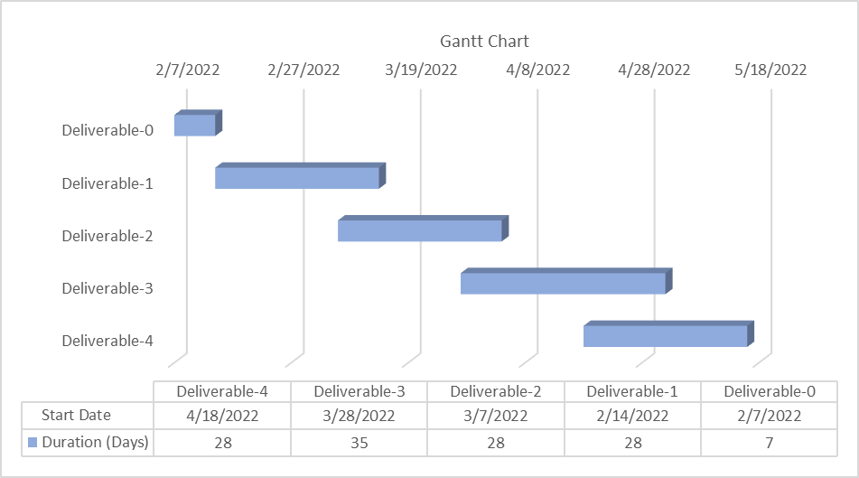

Below table shows date wise efforts done by team members.

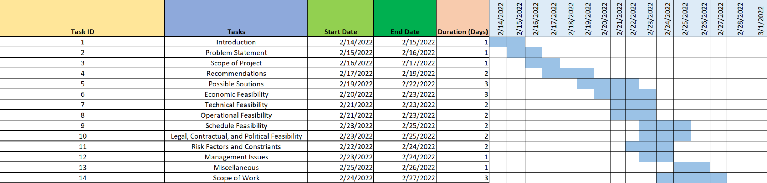

**Legal, Contractual, and Political Feasibility:**

To protect Catalent's intellectual property and trade secrets, all parties involved in the transaction must sign a confidentiality agreement before it can be completed and put into action. The terms and conditions of a company's contractual agreements must reflect the need to ensure that all employees (or new employees) utilize technology safely and responsibly. Project managers, senior management, and those entrusted with documenting and approving the project's finances in advance all participate in this process. Since this is an internal initiative, the firm will own the tools it purchases.

**Summary of Risk Factors and Constraints:**

| **Risk Factors** | **Solution** | **Mitigation** | **Constraints** |
| --- | --- | --- | --- |
| When MasterControl is down or has an issue. | Reach out to MasterControl Engineers. | Keep up to date with system maintenance and upgrades. | Training the new employees or current employees. |
| Security of the documents shared in the tool. | An admin will have right to control permissions for document access | Have Roles/permissions in place within the system for document access | Since this is a paid tool, the company has to purchase/renew the licenses. |
| Might have data loss in the process of migration. | Create a process for data to be backed up prior to migration. | Have a backup of all the documents prior to the migration. | If the tool is misused (sharing the information outside the organization) there might be legal issues that the company has to live with. |
| Push back from employees | Conduct training sessions for employees to feel comfortable with the system | Prior to the migration, have a sandbox environment for users to have visibility to this module | Employees may push back on this module since this is a new functionality for them. |

Two important risk factors:

1. When MasterControl is down or has an issue.

When MasterControl has any issues, employees can raise a ticket to the in-house admin team, which would be resolved if the admin team couldn't be able to resolve the issue that would be taken up by the MasterControl support team, where the support is included in the subscription.

1. Security of the documents shared in the tool.

 MasterControl has multi-layer security where once the employee logs in, there is a 2-factor authentication where the user must accept the notification they receive on the phone. Then, the user will get into the portal. And the user has only access to the company email, which makes it secure.

# Management Issues

All members of the group work together on the project, but in addition to working on the content of the project, everyone has an individual role:

| **Responsibility** | **Member** |
| --- | --- |
| Project Lead | Pravin Mohature |
| Customer contact | Usama Rehan,  Shikha Jaitwar |
| Researchers | Sravan Kumar Krovvidi, Sushmitha Reddy Kanapuram, Navneeth Rao Potheganti |
| Document Lead | Sudhanshu Jha, Sai Vineet Paladugu |
| Librarian, and Editor | Atefeh Jebeli |

All members of the group interact with each other through a WhatsApp group. In the group, the members talk about the time of the meetings, how their work is going, and so on. Meetings are also adjusted based on workload and how things are going.

On Google Meet, each deliverable usually requires 2-3 sessions. The initial meeting will focus on the deliverable, timeline, and task distribution based on the members' preferences. The second meeting will be used to discuss each member's efforts. Following that, each person discusses their opinions on a separate assignment. Following that, the appropriate individuals apply the final remarks, which will be discussed in the last meeting. The document is then finished with each member's approval. We may also increase the frequency of meetings for additional deliverables in the future if necessary to reduce mistakes and maintain the quality of deliverables.

# Miscellaneous

When we began a conversation with "Hamza Chaudhry," a coworker of one of our team members, Usama, added that the organization has difficulty obtaining permission for several papers. The organization works in a highly important subject, that of health care, which became even more important following the Covid-19 Pandemic. When we are in a group, we are talking about the same thing. We decided to come up with a solution and began brainstorming ideas.

We all met together with Hamza through Google Meet to examine the situation in further depth. Hamza said in the chat that they use the MasterControl program for internal training purposes. We investigated it and discovered that MasterControl's document management technology is quite helpful. We determined that MasterControl may be the finest option for Document Signature and Management after consulting numerous online sources and the company's official website.

Moreover, we refer to the company's website to access public information about its business, structure, clients, and so on. Also, some valuable information about the company is available on the Net. For example, there is some great information about its stock and finance on popular websites like Yahoo Finance, CNBC, and so on.

Additionally, some group members have had experience with similar tools, which worked like MasterControl, e.g., ServiceNow, SalesForce, and a similar problem like receiving paper-based IT requests. This experience gives the group members a good insight into this project.

# Scope of Work

All requests and incidents raised via Master Control will be stored on the company's server. This can be viewed by any other employee having the privilege to access the data. The Master Control tool has access to all the details of employees as it has access to the company's server. So, it reduces the work of capturing additional details of employees or their hierarchy. The tool has a feature to track the document signature request. Any employee who raised the request or incident can track it on their dashboard. There are notifications on the dashboard about the creation of the requesting form and after approval of the form. There are more modules in MasterControl than only Document and Incident management. Exams, Training, and Change, Audits and Preventive Actions, Risk, and Mitigation are some of the MasterControl modules that can be used in the future.

The future deliverables will have the analysis, system proposal, and design phases. The analysis phase has the requirement gathering and structuring in which it has Entity-Relationship diagram, Data flow diagram, Data dictionary of the system, and Walkthroughs.

# References

Dr. Rand Lecture slides (Slide 11-17)

**https://www.mastercontrol.com/company/**

[**https://www.itqlick.com/mastercontrol-documents/pricing**](https://www.itqlick.com/mastercontrol-documents/pricing)

**https://www.adobe.com/acrobat/about-adobe-pdf.html**

[**https://www.docusign.com/products/agreement-cloud**](https://www.docusign.com/products/agreement-cloud)

[**https://www.google.com/docs/about/**](https://www.google.com/docs/about/)

[**https://www.trustradius.com/products/mastercontrol-quality-excellence/reviews?qs=pros-and-cons#reviews**](https://www.trustradius.com/products/mastercontrol-quality-excellence/reviews?qs=pros-and-cons#reviews)

[**https://www.mastercontrol.com/quality/**](https://www.mastercontrol.com/quality/)

# Addressing Comments from D0

1) For the project title, it should be about a system. So, it could be e-forms Tracking System, etc. You ultimately decide that! My concern is the scope of your identified system (i.e., looking ahead, you will be asked to identify the Entity relationship diagram, data flow diagram for as-is versus to-be system, so how big/small is the scope of your improvement!!

We finalized the title as you suggested: E-Forms Tracking and Incident Management System.

2) You need to specify what the captured/collected/reported data needs to be about (i.e. the measures/indicators)? How will the clients' details be captured and/or tracked? More elaboration is needed on the scope of your improvement.

Covers under section - Scope of Work.

All requests raised via Master Control will be stored on the company's server. This can be viewed by any other employee having the privilege to access the data. The Master Control tool has access to all the details of employees as it has access to the company's server. So, it reduces the work of capturing additional details of employees or their hierarchy. The tool has a feature to track the document signature request. Any employee who raised the request can track it on their dashboard.